Day 32 , Employe ID : 1129116246

Task 1

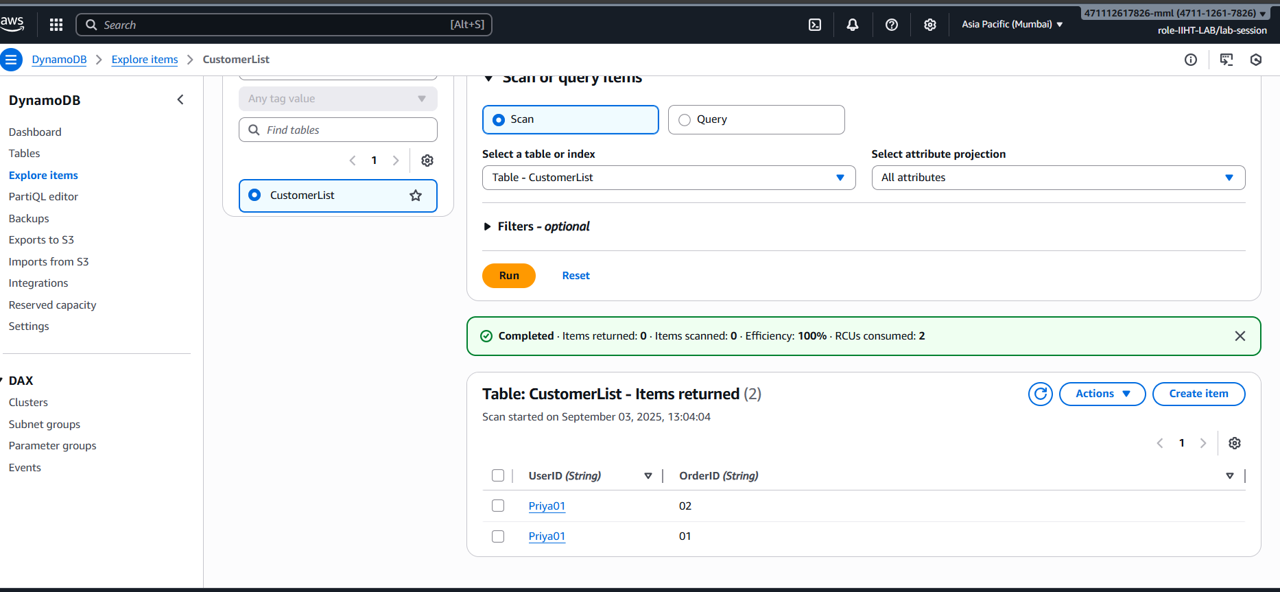

Add

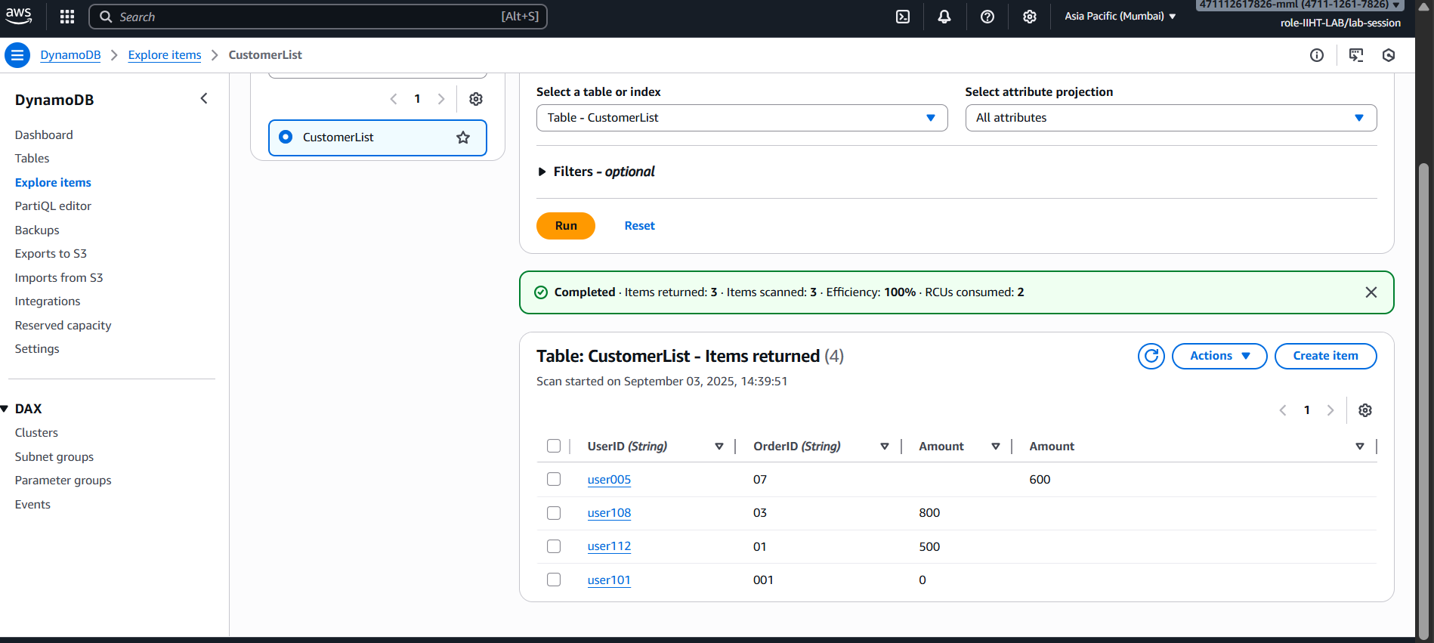

Delete

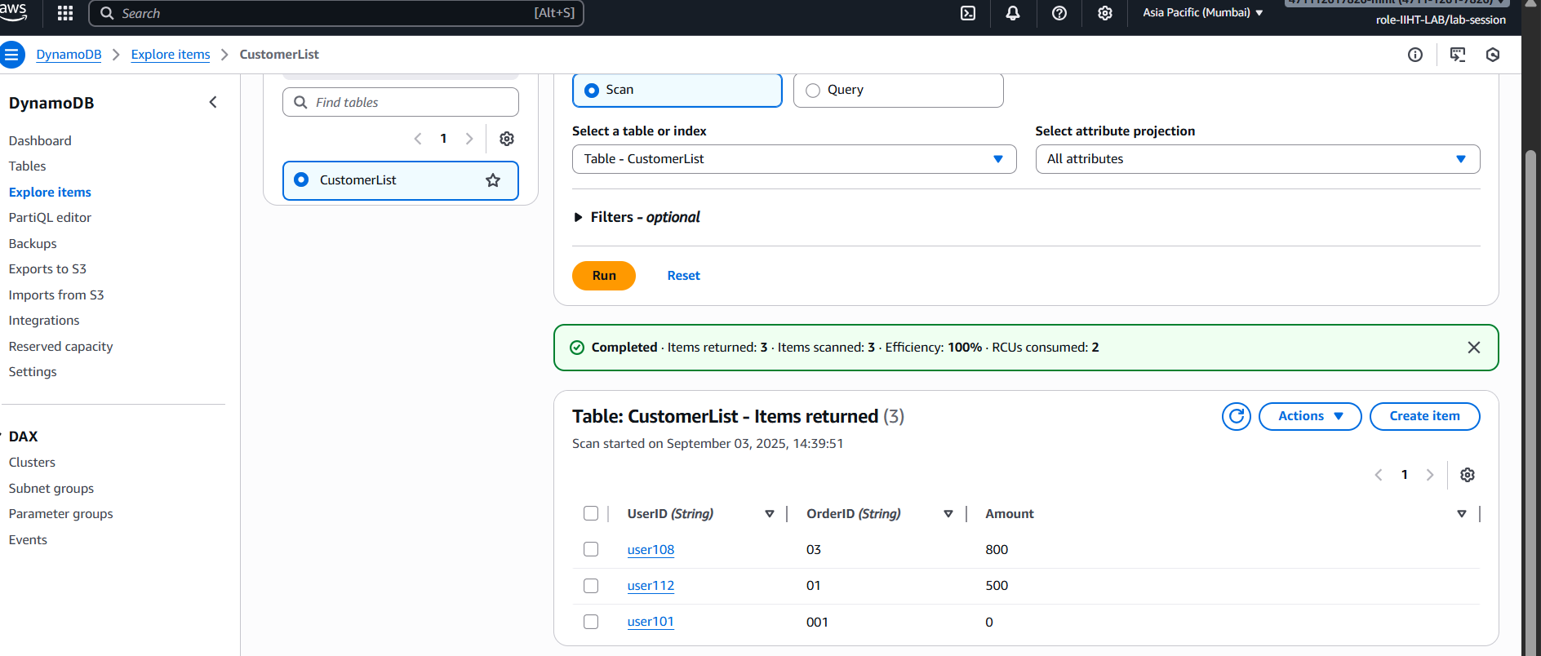

Update

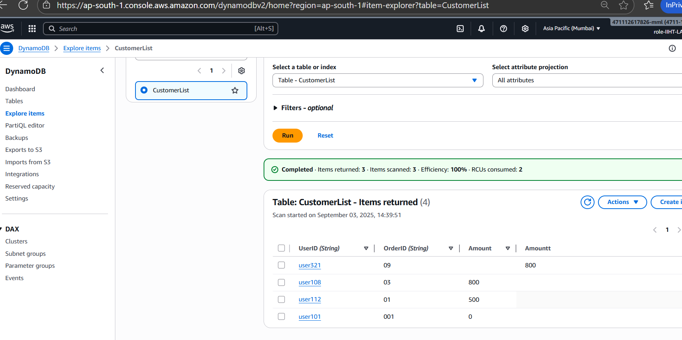

To this

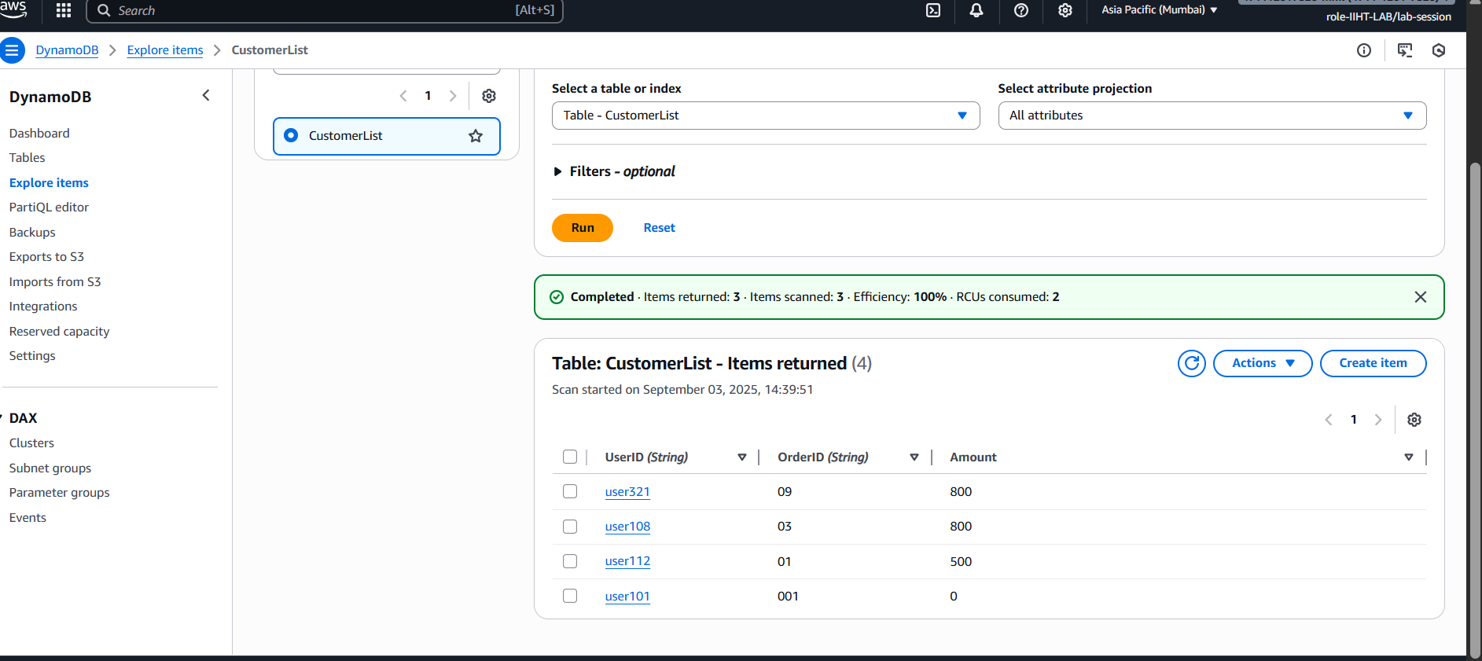

Script

Creating a table

aws dynamodb create-table --table-name Employee --attribute-definitions AttributeName=ID,AttributeType=N AttributeName=EmpName,AttributeType=S --key-schema AttributeName=ID,KeyType=HASH AttributeName=EmpName,KeyType=RANGE --provisioned-throughput ReadCapacityUnits=5,WriteCapacityUnits=5

configuring AWS CLI
install aws cli - aws cli
configure aws cli
aws configure
aws access key
secret key
region and output format

IAM permissions:

IAM user or role

CreateTable
PutItems
Getitems
Query
UpdateItems
DeleteItems
DeleteTable
---------------------------------------------------------------
Add custom IAM policy

aws iam create policy \
--policy-name
DynamoDBManagementPolicy \
--policy-document '{"Version" : "2025-05-20",
"Statement" :
[ {"Effect": "Allow", "Action" :
["dynamodb: CreateTable",
"dynamodb: Query", .......],
"Resource": "*" } ] }'

the above policy lets give to a role/user

aws iam attach-user-policy --policy-arn arn:aws:iam:: DynamoDBManagementPolicy
--user-name emp(here give the username for whom your want to attach the above policy)

create table
insert data
crud operAtions

---- GUI , CLI, SDK...

insert into table

aws dynamodb put-item --table-name Employee --item '{"ID": {"N": "1001"},
"EmpName": {"S": "Prasunamba"} }'

aws dynamodb put-item --table-name Employee --item '{"ID": {"N": "1001"},
"EmpName": {"S": "Prasunamba"} }'
.....

Query:

aws dynamodb query --table-name Employee
--key-condition-expression "ID = :ID"
--expression-attribute-values '{":ID":{"N":"1001"}}'

Update:

aws dynamodb update-item --table-name Employee
--key '{"ID": {"N": "1001"} , "EmpName": {"S": "Prasunamba"} }'
--update-expression "set info = :info"
--expression-attribute-values '{":info": {"S": "MK"}}'

Delete :

aws dynamodb delete-item --table-name Employee
--key '{"ID": {"N": "1001"}, "EmpName":{"S": "Prasunamba"} }'

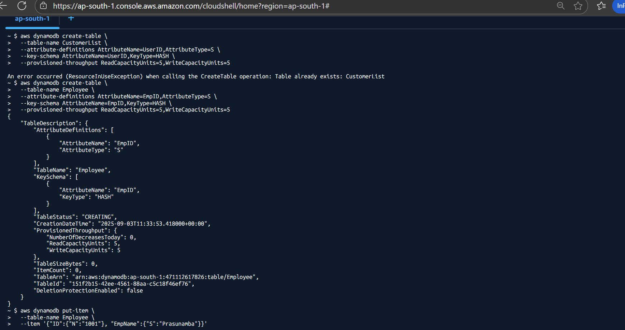

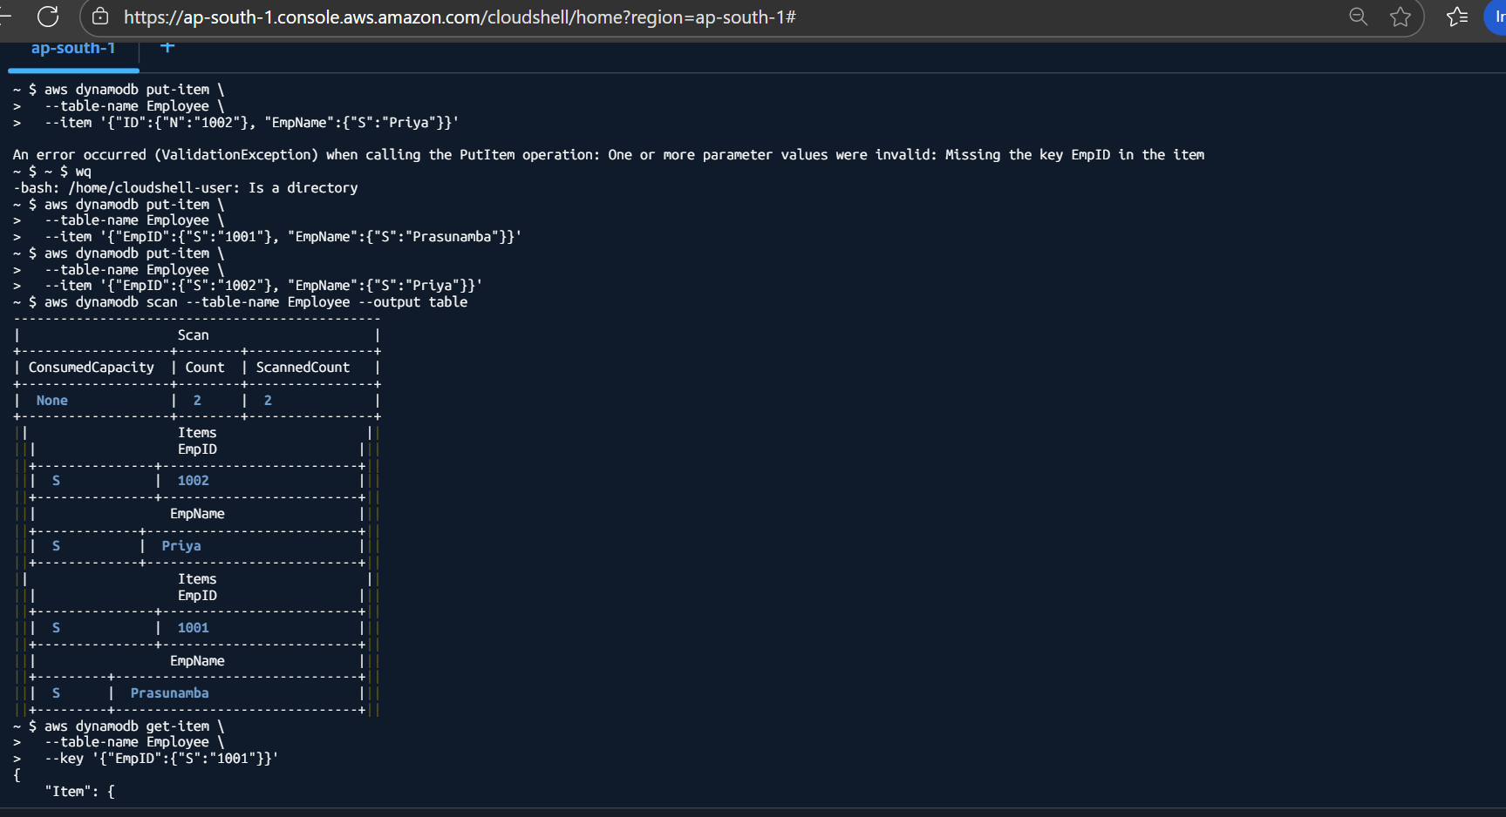

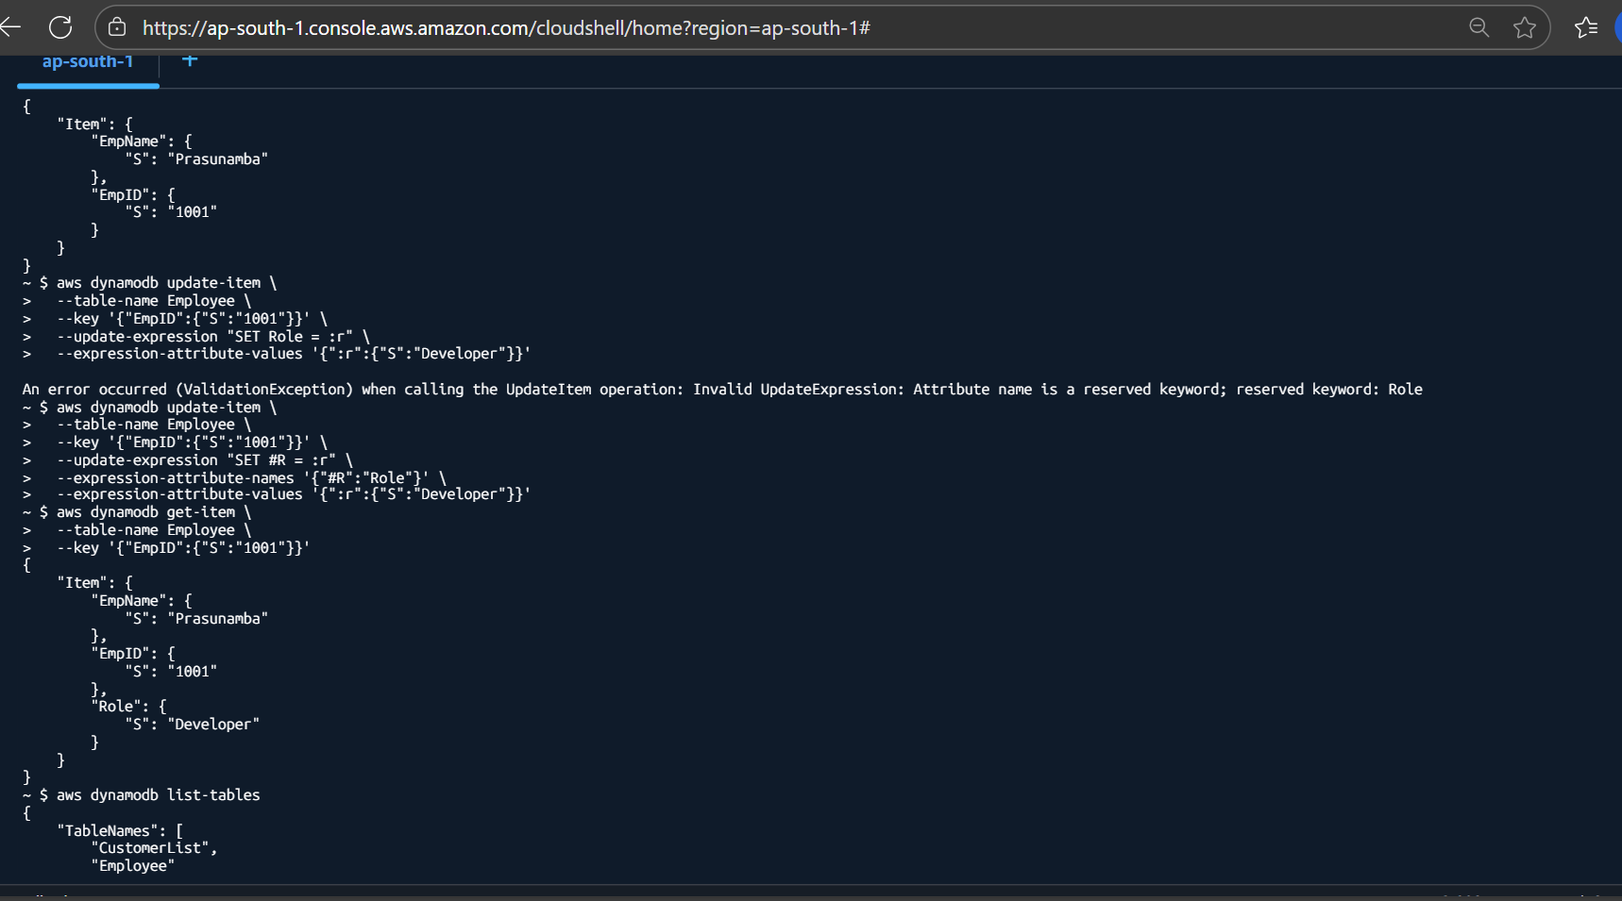

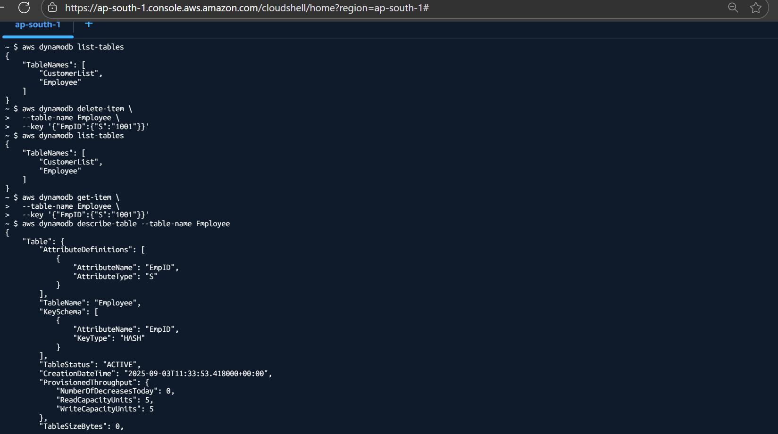

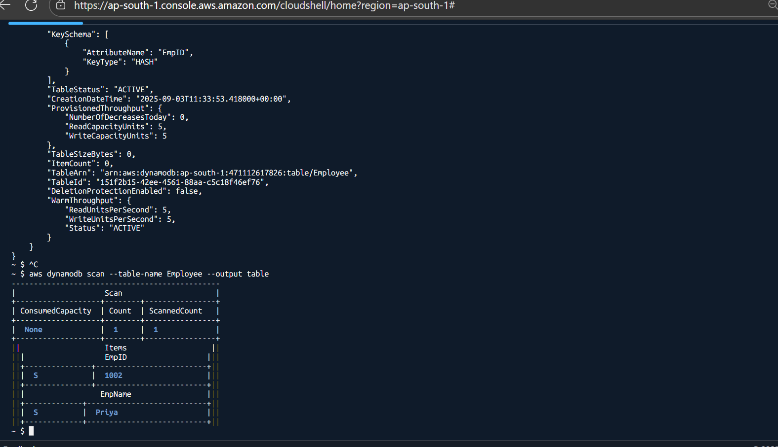

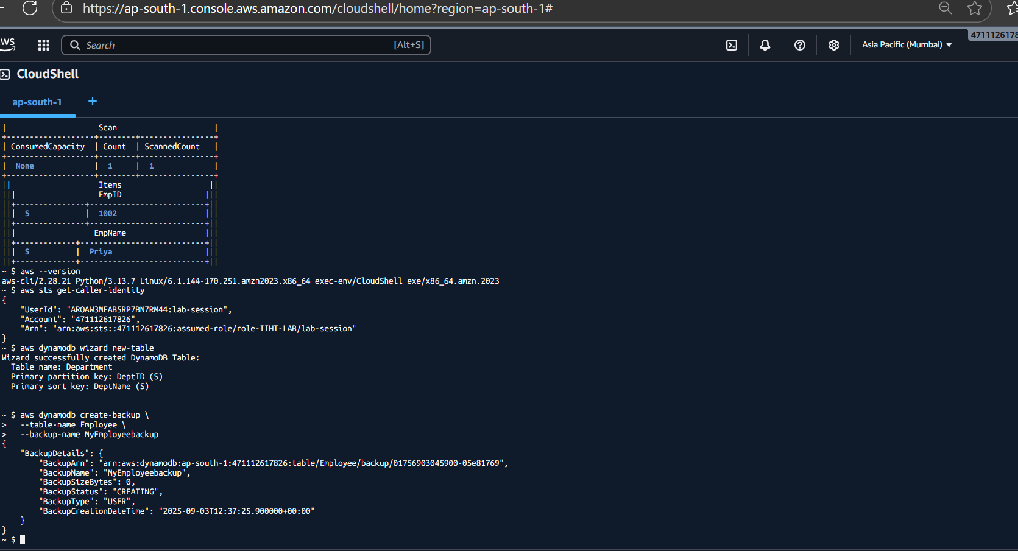

For HomeWork

Create 👍

aws dynamodb create-table \
--table-name Student \
--attribute-definitions \
AttributeName=StudentID,AttributeType=N \
AttributeName=StudentName,AttributeType=S \
--key-schema \
AttributeName=StudentID,KeyType=HASH \
AttributeName=StudentName,KeyType=RANGE \
--provisioned-throughput ReadCapacityUnits=5,WriteCapacityUnits=5

Put-item :

aws dynamodb put-item --table-name Student --item '{"StudentID":{"N":"101"}, "StudentName":{"S":"Priya"}, "Grade":{"S":"A"}, "Department":{"S":"CSE"}}'

aws dynamodb put-item --table-name Student --item '{"StudentID":{"N":"102"}, "StudentName":{"S":"Aman"}, "Grade":{"S":"B"}, "Department":{"S":"ECE"}}'

aws dynamodb put-item --table-name Student --item '{"StudentID":{"N":"103"}, "StudentName":{"S":"Riya"}, "Grade":{"S":"A"}, "Department":{"S":"ME"}}'

aws dynamodb put-item --table-name Student --item '{"StudentID":{"N":"104"}, "StudentName":{"S":"Mohit"}, "Grade":{"S":"C"}, "Department":{"S":"CSE"}}'

aws dynamodb put-item --table-name Student --item '{"StudentID":{"N":"105"}, "StudentName":{"S":"Meher"}, "Grade":{"S":"B"}, "Department":{"S":"ECE"}}'

Query :

aws dynamodb query \
--table-name Student \
--key-condition-expression "StudentID = :id" \
--expression-attribute-values '{":id":{"N":"101"}}'

Update item :

aws dynamodb update-item \
--table-name Student \
--key '{"StudentID":{"N":"101"}, "StudentName":{"S":"Priya"}}' \
--update-expression "SET Department = :d, Grade = :g" \
--expression-attribute-values '{":d":{"S":"IT"}, ":g":{"S":"A+"}}'

Delete :

aws dynamodb delete-item \
--table-name Student \
--key '{"StudentID":{"N":"101"}, "StudentName":{"S":"Priya"}}'

